**Excel Assignment - 16**

1. What is a Macro? How is it useful in excel or in your daily work?

Answer: If you have tasks in Microsoft Excel that you do repeatedly, you can record a macro to automate those tasks. A macro is an action or a set of actions that you can run as many times as you want. When you create a macro, you are recording your mouse clicks and keystrokes. After you create a macro, you can edit it to make minor changes to the way it works

--------------------------------------------------------------------------------------------------------------------

1. What is VBA? Write its full form and briefly explain why VBA is used in excel?

Answer: Visual Basic for Applications is a computer programming language developed and owned by Microsoft. With VBA you can create macros to automate repetitive word- and data-processing functions, and generate custom forms, graphs, and reports.

--------------------------------------------------------------------------------------------------------------------

3. How do you record a macro? Write detailed steps to create a macro to automatically make the following table in bold and to create borders for it in excel.

|  |  |
| --- | --- |
| hi | 78 |
| hello | 69 |
| ineuron | 45 |
|  |  |

**Before you record a macro**

Macros and VBA tools can be found on the Developer tab, which is hidden by default, so the first step is to enable it. For more information, see [Show the Developer tab](https://support.microsoft.com/en-us/office/show-the-developer-tab-e1192344-5e56-4d45-931b-e5fd9bea2d45).

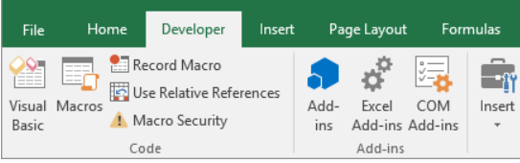

**Record a macro**

1. In the Code group on the Developer tab, click Record Macro.
2. Optionally, enter a name for the macro in the Macro name box, enter a shortcut key in the Shortcutkey box, and a description in the Description box, and then click OK to start recording.

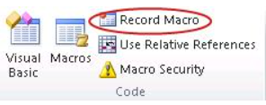

1. Perform the actions you want to automate, such as entering boilerplate text or filling down a column of data.
2. On the Developer tab, click Stop Recording.

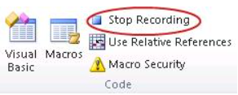

**TABLE FORMATTED:**

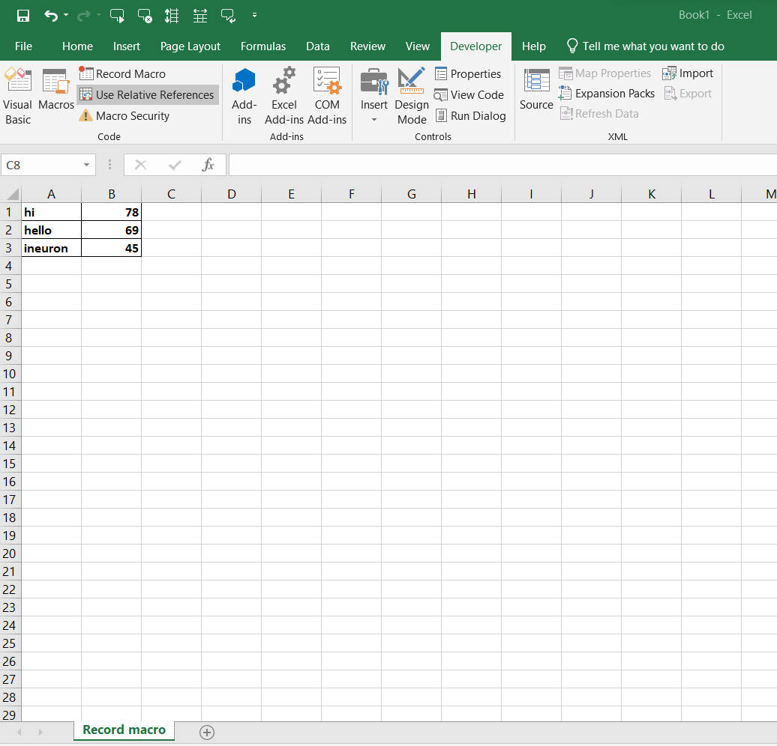

**Recorded Script:**

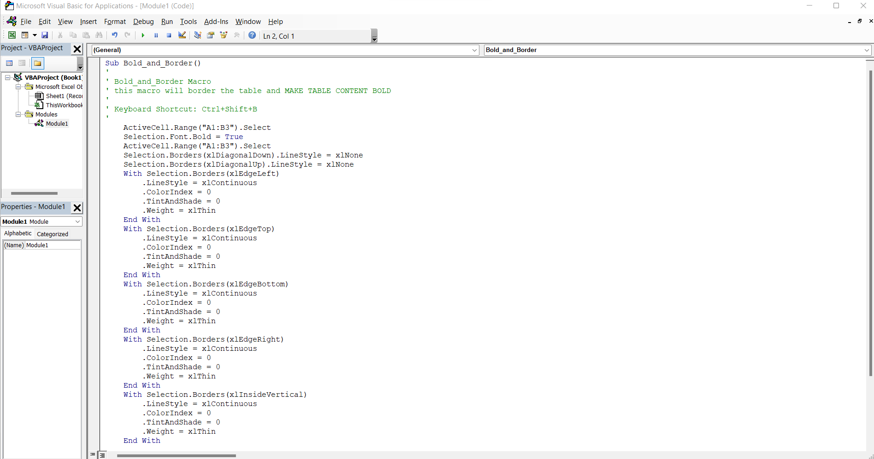

1. What do you mean when we say VBA Editor?

Answer: Microsoft Visual Basic for Applications (VBA) enables non-programmers to record, create, and edit macros that can automate tasks in Office applications.

--------------------------------------------------------------------------------------------------------------------

1. Briefly describe the interface of a VBA editor?

* What is properties window?

Answer : A property is a value or characteristic held by a Visual Basic object, such as Caption or Fore Color. Properties can be set at design time by using the Properties window or at run time by using statements in the program code. Object. Property = Value.

* And what is watch window?

Answer :

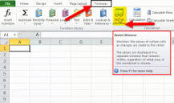

Watch Window in Excel is used to watch for the changes in the formulas we use while working with a large amount of data and formulas. They are available from the “Formulas” tab in the “Formula Auditing” section. When we click on the “Watch Window,” a wizard box appears.

* How do you display these windows?

Answer : They are available from the “Formulas” tab in the “Formula Auditing” section. When we click on the “Watch Window,” a wizard box appears.

1. What is an immediate Window and what is it used for?

Answer : The Immediate window evaluates expressions by building and using the currently selected project. To display the Immediate window, open a project for editing, and then choose Debug > Windows > Immediate or press Ctrl+Alt+I. You can also enter Debug. Immediate in the Command window.